
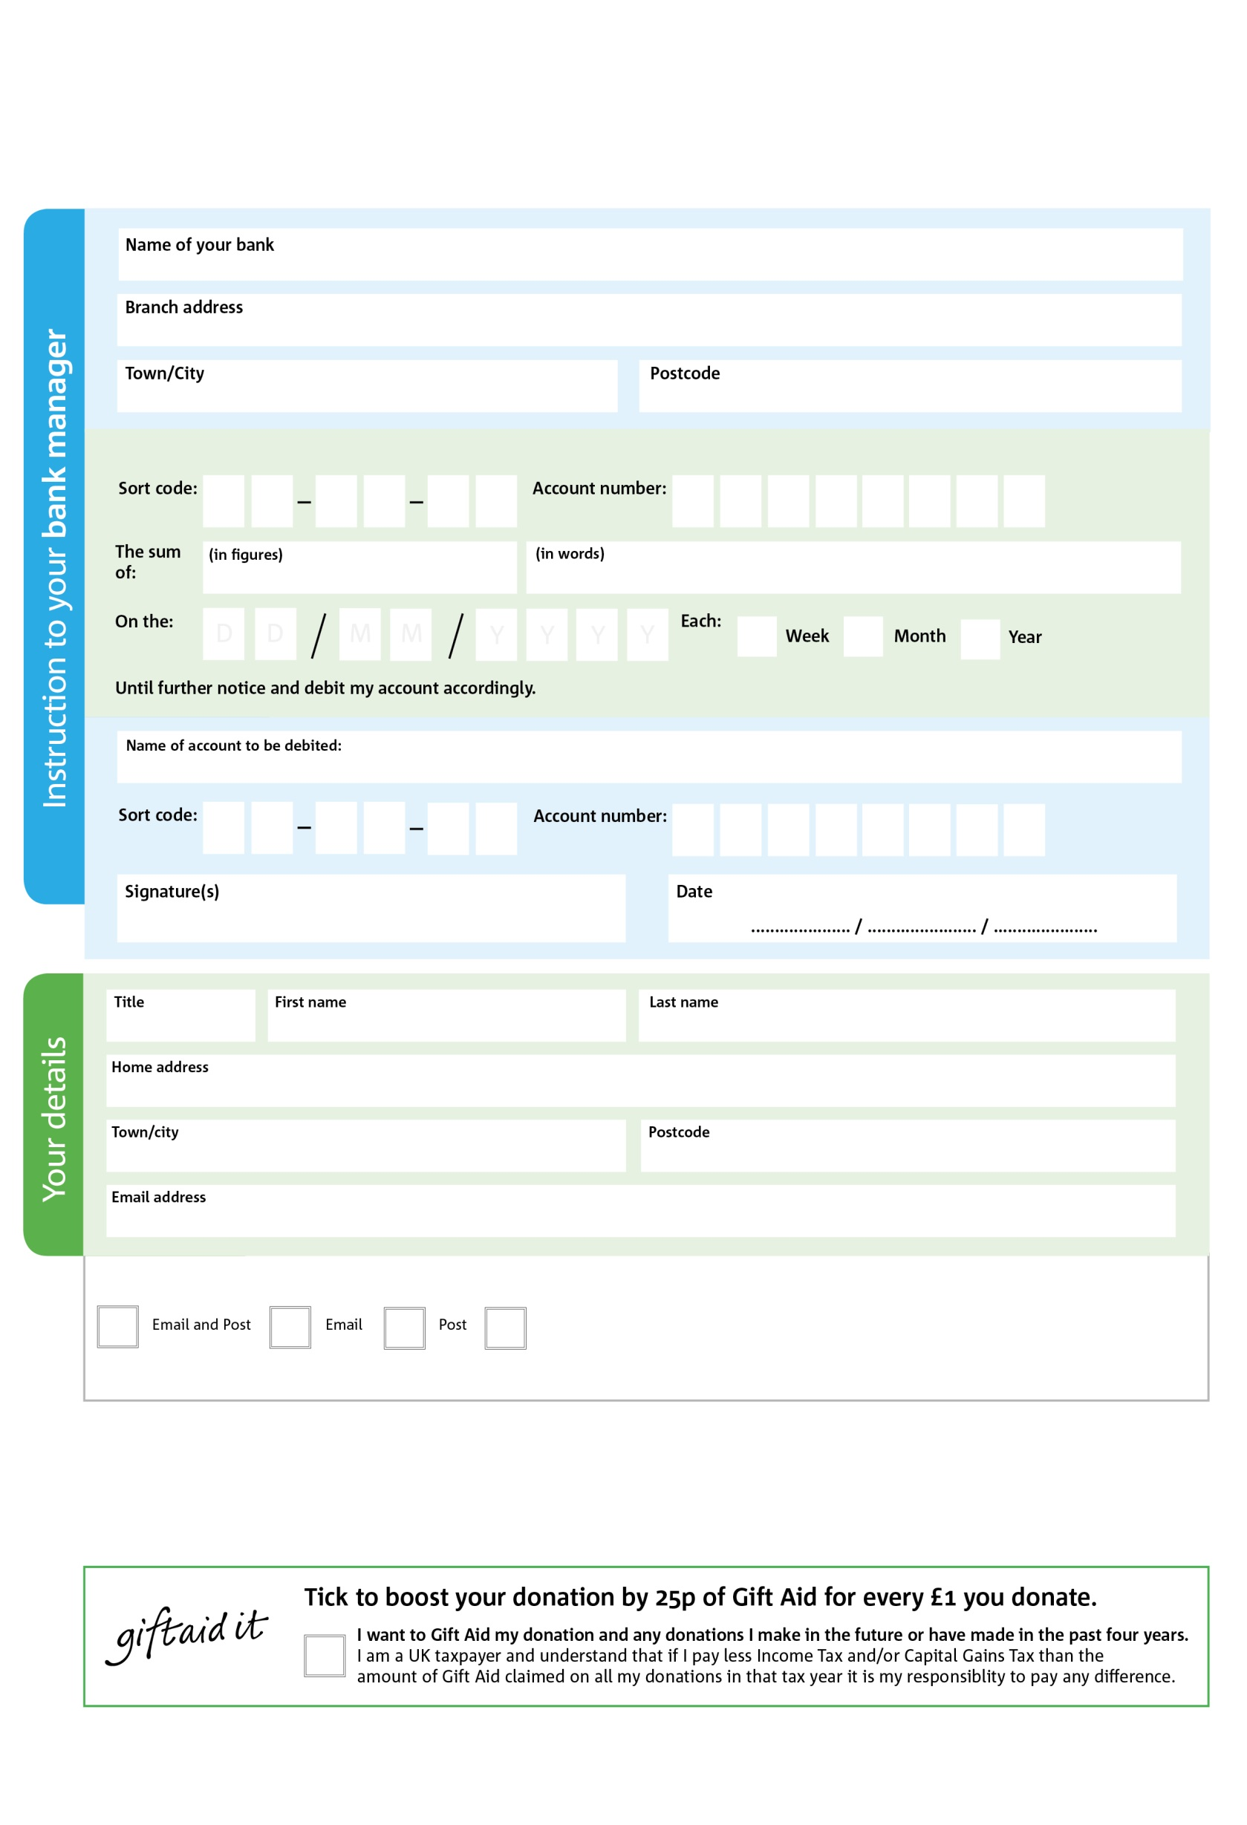
Reg. Charity No: NIC102799 | Reg. in Northern Ireland
Standing Order Mandate
info@magherafelt.foodbank.org.uk

Magherafelt Foodbank 19a Rainey Street, Magherafelt, BT45 5DA

8X

V
7X

V
2X

V
5X

V
2X

V
8X

V
2X

V
7X

V
Please pass this form onto the foodbank, using the foodbank’s address at the bottom, who will save a copy for their records.
They will then send it onto your named bank or building society.

8X

2X

1X

0

9X99

0

We would love to keep you up to date with information about Magherafelt Foodbank. Please tick your preference:

You can change your preferences any time by contacting us on 07393451504 or emailing us at info@magherafelt.foodbank.org.uk
I do not wish to receive future communications from Magherafelt Foodbank

Please pay Magherafelt Foodbank,

Data protection
'Magherafelt Foodbank is committed to protecting your privacy and will process your personal data in accordance with current Data Protection legislation. Magherafelt Foodbank collects information to keep in touch with you and supply you with information relating to our work. To unsubscribe from our newsletter, send a message to the email address above with the word unsubscribe in the subject line. A full data privacy statement for financial donors is available from the foodbank on request.’

You can change your preferences any time by contacting us on XXXXXXXXXXX or emailing us at XXXX@XXXXXXXXXX.foodbank.org.uk

I do not wish to receive future communications from XXXXXX Foodbank

